Decision Support System for Sugar Regulatory Administration

Bryll Joey Delfin1, Michael Gerald Gochioco2, Natraj Rajput3 JaysonRevidad4

and Ms. Lissa Andrea K. Magpantay1,*

*De La Salle University, IT Department*

*\* lissa.magpantay@delasalle.ph*

**Abstract:** The sugar industry is important because it is responsible for supplying the world with sugar, which is used in many types of dishes and products, and sugar in itself is an important part of the human diet. Sugar is also found in many staple foods. The world produces 170 million metric tons of sugar every year. Brazil was the top producer and exporter of sugar in 2013-2014. The United States produced 7.67 million metric tons of sugar in 2013-2014. For the crop year of 2014-2015, the Philippines produced a total of 2,323,817 metric tons of raw sugar that came from 416,893 hectares of sugarcane. The yield per hectare was 111.48 Lkg/Ha. In the same crop year, 1,076,382 metric tons of sugar were produced. With this, it can be seen that the sugar industry is very important especially for a country like the Philippines.

This paper presents the development of a Decision Support System for Sugar Regulatory Administration. The system covers the processes of SRA that relates to data gathering, processing and assistance.

Based on the observations and interviews conducted, the proponents have found that the main problem encountered by the company is that they are having difficulty in providing appropriate programs and recommendations to farmers.

The main objective of this study is to assist the agriculturists and mill district officers in deciding and providing recommendations to the farmers faster. Another objective is, to help the board of directors decide what programs to provide for the farmers based on the problems that farmers are encountering. The methodology used in this study was Agile. the tools used were Netbeans, JQuery, BootStrap, Android, HighCharts and MySQL. A user acceptance test was conducted for the users of the system and the results were good. The proponents conclude that the proposed system would be beneficial for the sugarcane farmers both long term and short term in terms of their productivity. The system would also be valuable for the organization for they would be able to focus on the root problems and key results.

**Key Words:** Decision Support System; Recommendations, Programs, Farmer

1. INTRODUCTION

As stated in Section 2 of the Republic Act No. 10659, It is now a policy of the State to promote the competitiveness of the sugarcane industry and maximize the utilization of sugarcane resources, and improve the incomes of farmers and farm workers, through improved productivity, product diversification, job generation, and increased efficiency of sugar mills; For these purposes, the state shall establish productivity improvement programs, provide the needed infrastructure support and enhance research and development of other products derived from sugar, sugarcane, and their by-products. However, despite the efforts of the government and the private sector, improving yield production and providing assistance to the farmers by the masses has been a tedious and difficult task.

The country is having difficulty in meeting the sugar cane demands and quota of the local market as well as the international market. As of 2012, The Philippines Sugarcane Industry contributes no less than P70 Billion to our economy annually. Out of the total land area of about 30 million hectares, sugarcane is planted to about 422,500 hectares in the Philippines, with about 62,000 farmers. In terms of farm sizes, 75% of farms have sizes less than 5 hectares and another 11% have sizes of 5 to 10 hectares. Of the remaining farms, 11% have sizes 10 to 50 hectares and a mere 2% have sizes 50 to 100 hectares, while only 1% with a size of over 100 hectares. So providing suitable programs and assistance to only farmers with big land area would not be sufficient. Finding a solution that will not only benefit the organization and all the farmers, but the whole sugarcane market itself would definitely be beneficial.

One of the main reasons it is difficult to provide recommendations and programs is because, most of the time spent is in the gathering and consolidating of data using surveys with the help of surveyors and agriculturists. There are other countries however that use more sophisticated means of data gathering like with the use of Geographic Information Systems(GIS), Satellites and Remote Sensing. These devices and technologies could definitely ease and automate the process of data gathering but they are still relevantly new to countries such as the Philippines and so access is limited, expensive, and requires a lot of time and effort to acquire, implement and train. An effective way of simplifying the data gathering process and reaching out to farmers would be by using existing technologies; such as smartphones and the internet. Adding a mobile application along with a DSS would definitely help SRA focus on the decisions and help the farmers get easy access to various practices and solutions.

A decision support system (DSS) is a computer application that analyzes business data and presents it so that users can make business decisions more easily. DSS are usually made to handle management, operations, and planning decisions. Some DSS applications are developed specifically to provide tools and recommendations that can help its users identify solutions for problems that were detected. DSS can be applied to different fields, such as medical diagnosis, engineering projects, business management, and agricultural production at farm and policy levels. (“Decision Support System (DSS)”, n.d.)

The Decision Support System we created is divided into three modules namely: Data Acquisition Module, Crop Estimation Module, and Programs, Farmer Recommendation and Assistance Module.

The Data Acquisition module will focus on acquiring the needed data for analysis for the following module. Using a mobile application, a farmer will be able to plot the area of their farm using the geographical map to determine the area harvested and this data is synced to a common database. Other surveys are conducted to determine updates to their field and the crops as well as record any problems they have encountered or are encountering. The MDO can see the updates done by the farmers when necessary. The surveys of all the farmers are consolidated for the use of the next modules.

The Crop Estimation Module handles the generation of estimates. For the initial estimate of the year, the system uses data of the previous crop years. Throughout the year, the estimate is adjusted on a weekly basis. The crop estimate and productivity uses the data gathered from the previous module. Crop estimate will be determined by the use of simulation models that can help derive to a reliable forecast. The estimates are used in making decisions for the allocation and pricing of sugar. The system can provide updated information and reports necessary to a more accurate sugar allocation to both national and international markets without spending considerable amount of time in organizing, consolidating and understanding the data.

The Last Module (Programs, Farmer Recommendation and Assistance Module) is divided into sub-modules. The first submodule relates to the creation of programs. The board members are responsible for creating programs for each of the 33 districts. Considerable amount of time is spent in trying to identify the problems that farmers are facing in a district due to the limited information and time constraints. This makes it hard to know what issues they need to prioritize and address. Now that farmers are able to report the problems they are encountering using the mobile device, board members are able to use this data to effectively prioritize and create programs to the farmers and places that need it most. Details of existing programs can also be seen. The system records the productivity from before, during and after the program has been implemented. Based on this, the board members can use it as basis to see the effectiveness of the program.

The second submodule handles the farmer recommendations. The MDO and agriculturists of every district are responsible for providing assistance to the farmer in respect to their crops and practices. At the present time however, this may only be done when the agriculturists go to each farm to survey. The agriculturists cannot spend much time helping a farmer as they are required to survey all farmers in a district. In Luzon, each district has approximately 600-1000 farmers with about 4000 farms. If the farmers were to report their problems and the various practices they do using their mobile devices, the system can automatically provide them with any existing recommendations and practices. With the DSS, comparative analysis can be done between farms in order to determine optimal farming practices. Farming recommendations include practices that affects irrigation, drainage and cultivation. All the provided recommendations can be viewed by the farmers from their mobile application and can be filtered based on their classification. Ex. fertilization, irrigation, replanting, etc.

The last submodule handles farmer assistance and aims to alert farmers. The mill district officer can send weather updates to the farmers, notifying them about an upcoming typhoon and also recommend the farmers to harvest the remaining crop. The farmer will be notified thru the mobile application and can decide whether or not to comply. Additional updates can also be given to the farmers as needed. The farmers may also inquire through the mobile application if they have questions or concerns regarding their farms. Through the forum feature of the mobile application, a farmer may ask for assistance from the MDO or other farmers regarding any concerns or questions they have. Having an effective way for farmers to communicate with other farmers and experts, one should be able to see an improvement in the productivity of a district as a whole.

If farmers are assisted throughout the year with an effective way for farmers to communicate with other farmers and experts, one should be able to see noticeable improvement in productivity right from each farm to the whole sugar industry.

1. METHODOLOGY

The methodology used in this study is Agile. The group conducted multiple interviews with the department head, Mr. Fernando Corpuz, chief agriculturist Mr. Maximo Pelle and also with the Tarlac mill district officers, Mr. Joel Ronario and Mr. Laverne Olalia. The interviews were used to identify various IS-related problems, and also as an in-depth guide to the company’s processes, policies, problems and solutions. The group also researched and looked into different Agriculture Systems and DSS that were used to benchmark and improve the overall project.

The researchers used Java, JavaScript, bootstrap, Highcharts, MySQL and Android language for the development of both the system and the mobile application. Weekly consultations with the adviser were conducted to guide the project and its modules to the right direction. Daily meetings were also conducted. The meetings were used to design, analyze and validate the pages as to meet the requirements of the proposal, company rules and maintain its usability. During the project’s final stage, system testing was conducted as well as the user acceptance testing with the help of two department managers and two farmers. The manual was produced to assist the users in understanding the system’s flow and maximize its functionalities.

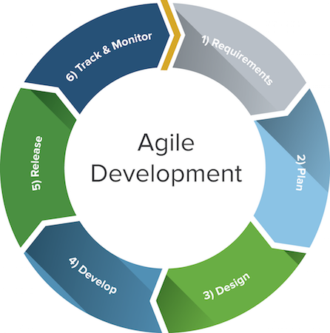

Figure 1: Agile Methodology

1. RESULTS AND DISCUSSION

Based on the data gathered and interview conducted by the proponents, Sugar Regulatory Administration’s main problem is the difficulty in providing appropriate programs and recommendations. The proposed solution has 3 main modules.

User acceptance testing was conducted to know if the proposed system would be beneficial for the users. For the main features and functionalities, the mill district officer was satisfied. He would like to have the system implemented at least in his district because it would make his work easier and he could focus on research and helping the farmers. Another reason is because, he would be able to handle and access large amounts of data a lot more efficiently since it is consolidated and processed immediately on submission. An example would be in the creation of farm observation and comparison. The data of each farm is properly consolidated and so it can be used to effectively identify problems and send appropriate recommendations. That is very critical for helping the farmers in improving their yield which would increase overall production. The farmers found the mobile application to be very interesting and convenient. They found the forum very useful for communicating with the mill district officer and other farmers for their concerns. Their only concern is that they would prefer to have it in their own dialect. The board members found the DSS to be very interesting and practical. They said that it can actually work in real life application. They would however like to have a complete business solution based on this system that would cover their other processes in the organization that is not part of our scope.

Overall, the users of the system found the proposed system to be very valuable and productive as it can make their decisions clearer and faster.

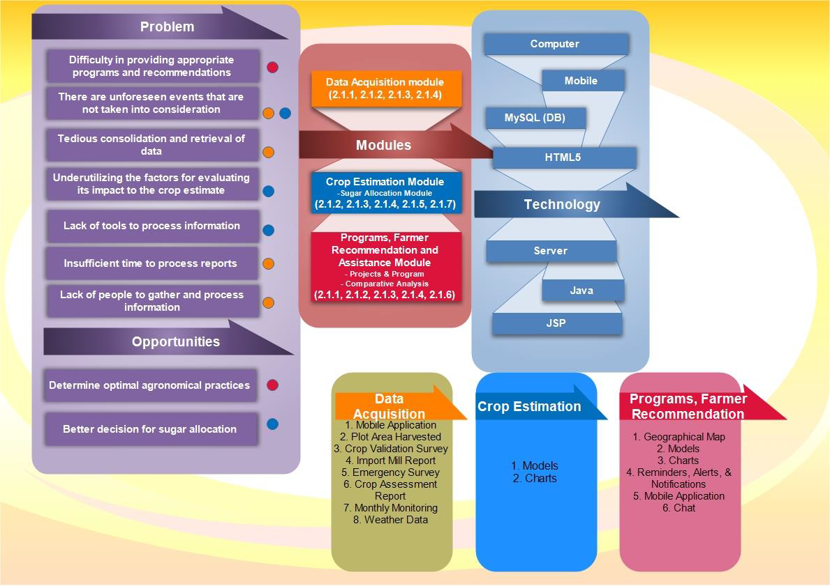

Figure 2: Conceptual Framework

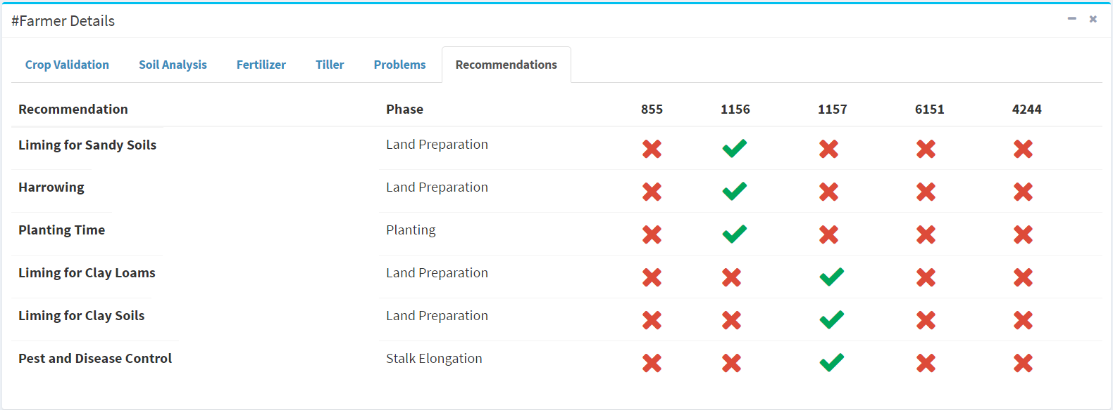

Figure 3: Farm Comparison Page

1. CONCLUSIONS

The proposed Decision Support System would greatly benefit SRA especially in their extensions services to the farmers. The system will help the mill district officer assist and monitor the farms within his district better. Communication between mill district officer and farmer will also improve with the use of the mobile application. The crop estimate is automated which can help the user evaluate different forecasts when they conduct their own tests. The proposed system is ready to be installed on the offices’ computer since system testing has been conducted to ensure proper installation. The mobile application will be installed on the farmer’s phone and they can be registered in the system so that the mill district officer can monitor them. Internet connection will be used in order to properly connect the web and mobile application. The mobile application based on our research is feasible because most of the farmers do in fact, have their own smartphones in which the mobile application can be installed. Farmers who do not own a smartphone can be provided one. For the rest of the farmers who do not have access to a smartphone, the mill district officer himself can use his own version of the mobile application to survey.

The proposed system may also be of help to other agricultural sectors. This can be used as a reference for future researches that relates to agricultural decision support systems. When everything in the world is becoming more accessible, mobile and affordable, the agricultural sector of the Philippines should not be left behind. The Philippines should use the opportunity to strive to help its farmers through the application of new research and technology in order to stay competitive in today’s International Market.

1. ACKNOWLEDGEMENTS

The research proponents extend their deepest gratitude to the Sugar Regulatory Administration especially to the following: Extension services manager Mr. Fernando Corpuz, Planning Department manager Ms. Rosemarie Gumera, Agriculturists Mr. Maximo Pelle, Mr. Laverne Olalia and Mr. Joel Ronario. We also thank the 2 farmers that helped test our mobile application.

1. REFERENCES

Decision Support System(n.d.) Retrieved December 21,2016 from https://www.techopedia.com/definition/770/decision-support-system-dss

Official Gazette (2015, March 12). Republic Act No. 10659. Retrieved December 21,2016 from http://www.gov.ph/2015/03/27/republic-act-no-10659/

The Philippine Sugarcane Industry: Challenges and Opportunities(n.d.). Retrieved December 21,2016 from https://www.sra.gov.ph/the-philippine-sugarcane-industry-challenges-and-opportunities/

Sugarcane Roadmap 2020(September 2015). Retrieved December 21,2016 from http://www.sra.gov.ph/wp-content/uploads/2016/03/SUGARCANE-ROADMAP-2020_final_03022016.pdf

Statistics and facts about the Sugar Industry(n.d.) Retrieved December 21,2016 from

http://www.statista.com/topics/1224/sugar/

Organizational-Statements.pdf Decision Support System(n.d.) Retrieved December 21,2016 from https://www.techopedia.com/definition/770/decision-support-system-dss

The importance of Agriculture (2016, November 3). Retrieved December 21,2016 from http://agriculturegoods.com/the-importance-of-agriculture/